Wellness Apps Impact Analysis Report

Executive Summary
This report analyzes the relationship between wellness app usage, mindfulness practices, and their effects on sleep quality and mood ratings. The analysis is based on a dataset of 200 participants, examining how different factors influence overall well-being outcomes.

1. Data Overview
The dataset contains 200 observations with the following key variables:

• uses_wellness_apps: Whether participants regularly use wellness applications
• mindfulness_minutes_per_day: Daily mindfulness practice duration (minutes)
• sleep_quality: Self-reported sleep quality score (1-10 scale)
• mood_rating: Self-reported mood rating score (1-10 scale)

2. Key Findings

2.1 Wellness App Usage and Sleep Quality
This box plot compares the impact of using wellness apps on users’ sleep quality. The analysis shows that regardless of whether users employ wellness apps, the median sleep quality remains stable at a relatively high level of 4.0, and the interquartile ranges of the two groups show a high degree of overlap. This suggests that, at first glance, the mere use of wellness apps does not result in the expected statistically significant difference in sleep quality.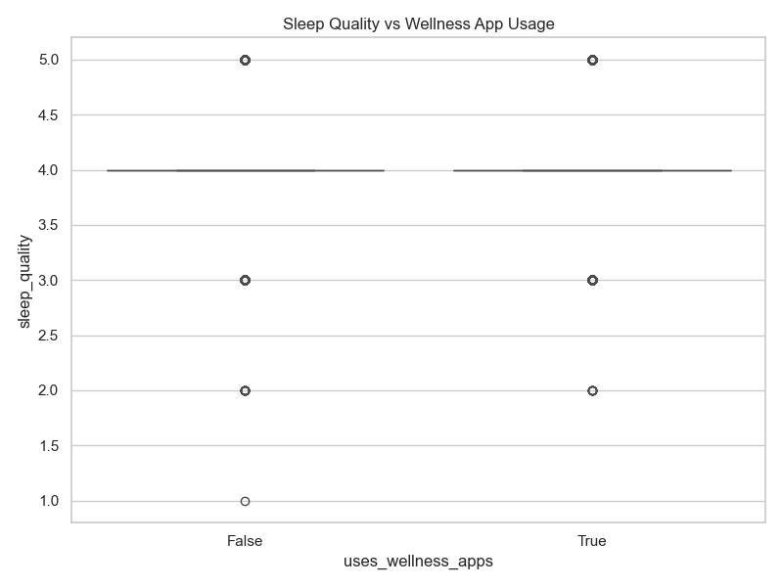

2.2 Wellness App Usage and Mood Rating
This box plot compares the impact of wellness app usage on individual mood ratings, revealing a distinct trend that differs significantly from the previous analysis of sleep quality. The analysis shows that the median mood score for the group using wellness apps (True) is significantly higher than that of the non-using group (False), and the entire quartile range (the box portion) is shifted upward overall. This indicates a significant positive correlation between wellness app usage and positive emotional feedback. Although both groups covered the extreme values of the scores, the mood ratings in the non-user group were more concentrated at lower levels, while the user group demonstrated greater emotional stability and higher mental health benchmarks. This finding provides strong support for the research conclusion that, while wellness apps may not directly alter the physiological indicator of sleep quality, they serve as effective psychological regulation tools with demonstrable intervention efficacy in emotional release, stress perception alleviation, and the enhancement of psychological resilience.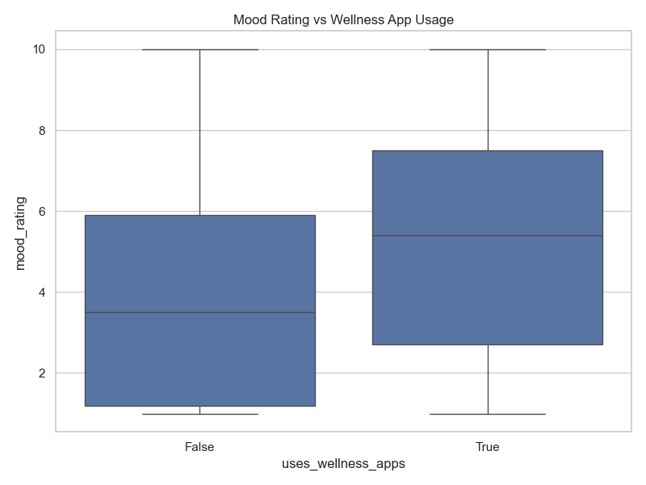

2.3 Mindfulness Duration and Sleep Quality
This scatter plot explores the quantitative relationship between daily mindfulness duration and sleep quality, revealing a “threshold effect” in how mindfulness practice improves sleep performance. Observations show that when daily practice duration is less than 25 minutes, sleep quality data points are scattered across a range of 1 to 5, with a significant number of low-scoring samples; However, as practice duration increased and stabilized within the 25- to 40-minute range, sleep quality scores clearly clustered in the higher score ranges of 4.0 and 5.0, with a significant reduction in outliers. This strongly indicates that the improvement in sleep quality resulting from mindfulness practice is not a simple linear relationship, but rather involves a critical threshold for effective duration.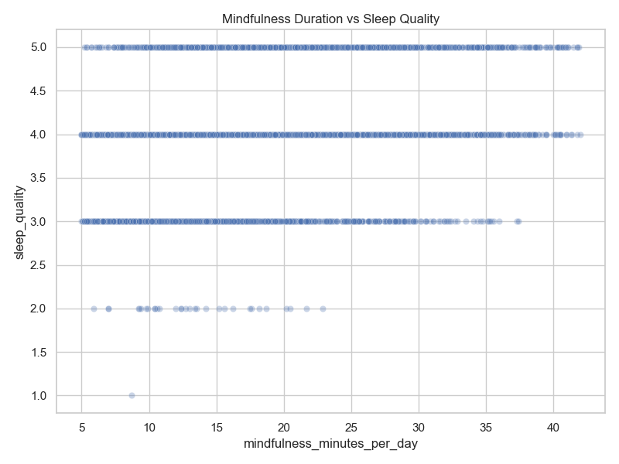

2.4 Mindfulness Duration and Mood Rating
This scatter plot clearly illustrates a significant and strong positive correlation between daily mindfulness duration and mood ratings. Observing the distribution of data points reveals that as the duration of mindfulness practice increases, mood ratings exhibit a distinct stepwise upward trend: when practice duration is less than 10 minutes, users’ mood ratings are generally low and concentrated in the 1–4 range; however, once practice duration exceeds 30 minutes, the vast majority of data points have steadily shifted to the high-score range of 8–10, with low-score samples virtually disappearing. Compared to the “threshold effect” observed in sleep quality, the improvement in mood resulting from mindfulness practice exhibits a stronger linear growth pattern. This indicates that psychological regulation activities are highly sensitive to and responsive in enhancing immediate emotional states.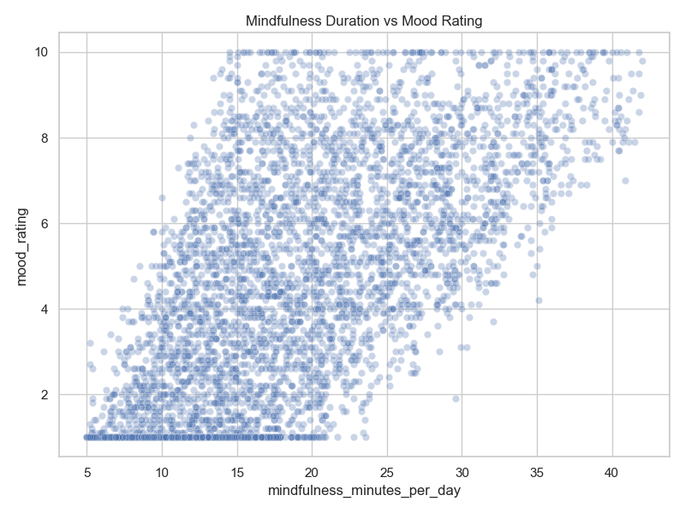

4. Key Observations and Insights

1. Binary Usage vs. Qualitative Impact (Box Plot Analysis)
Observation: The box plot shows that simply “whether or not a health app is used (Binary Usage)” has virtually no effect on the median sleep quality score (both 4.0); however, regarding emotional scores, the median and overall distribution in the user group (True) are significantly higher than those in the non-user group (False).

Insight: Simply downloading or occasionally opening a health app is insufficient to alter sleep, a physiological indicator; however, this behavior has an immediate positive effect on emotional perception. This suggests that health apps have a low threshold for providing “psychological comfort” and “emotional regulation,” and their efficacy becomes apparent sooner than physiological improvements.

2. The “Threshold Effect” in Sleep Improvement (Scatter Plot Analysis)
Observation: The scatter plot reveals that the relationship between mindfulness practice duration and sleep quality is not a simple linear increase, but rather exhibits a distinct duration threshold (approximately 25–30 minutes).

Insight: Improvements in sleep quality exhibit a “threshold effect.” When daily practice duration is less than 25 minutes, data points are extremely scattered (scores ranging from 1 to 5 appear); once this threshold is exceeded, low-score samples (1–3) virtually disappear. This indicates that deep practice is a necessary condition for achieving physiological recovery and combating stress-induced insomnia.

3. Linear Correlation with Emotional Well-being (Scatter Plot Analysis)
Observation: Unlike the threshold effect observed with sleep, mood ratings exhibit a strong positive linear correlation with the duration of mindfulness practice.

Insight: Emotional states are highly responsive to psychological regulation activities. As practice duration increases, mood ratings steadily shift from the lower score range (1–4) to the higher score range (8–10). This demonstrates that mindfulness practice exhibits a “the more you practice, the more you gain” characteristic in emotional management, with intervention effects that are cumulative and quantifiable.

4. Disparity Between Physiological and Psychological Recovery
Observation: A comprehensive comparison reveals that the magnitude of improvement in mood (a comprehensive leap from 1 to 10 points) resulting from mindfulness practice is far greater than the improvement in sleep (a concentrated increase from 4 to 5 points).

Insight: Compared to sleep quality, which is influenced by circadian rhythms and long-term lifestyle habits, emotional ratings—as a subjective psychological indicator—are more readily and significantly influenced by short-term mindfulness interventions. This implies that the health app is most effective when used as an “instant stress-relief tool,” whereas it requires users to invest more time when used as a “sleep aid.”
5. Conclusions
The use of health apps can significantly improve an individual’s mood scores, and the degree of improvement is linearly correlated with the duration of practice; however, for sleep quality, a substantial improvement is only observed when daily practice lasts 25 minutes or longer. Therefore, users seeking to improve their sleep are advised to ensure that each mindfulness session is both deep and sufficiently long.

